**ARTIFICIAL INTELLIGENCE**

**ASSIGNMENT – 4**

**WORKFLOW:**

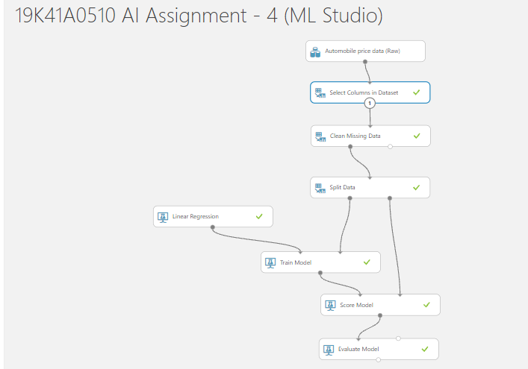

**EVALUATION RESULTS:**

